Team: Aditya Khanna (ak34642) and Hubert Ning (hfn88)

Instructor: Dr. Eberlein

**Our Green Routine - EE 461L Project Pitch Report**

**The Problem and Our Motivation:**

The key issue today with our recycling system isn’t that we’re not doing enough of it, but that we’re not doing it correctly. For example, since 2015, nearly 90% of all recycled plastic items end up in landfills or are burned[1]. That means nearly 90% of what we recycle is harming our environment and going against our very efforts to save the Earth. Our proposed web application (*Our Green Routine*) addresses pollution and climate change; we aggregate all relevant information regarding waste reduction for individuals who are invested in recycling. Our comprehensive web application will delineate all pertinent information for recycling (in Texas) in one convenient location – which ameliorates the user experience by making recycling more accessible and efficient.[2]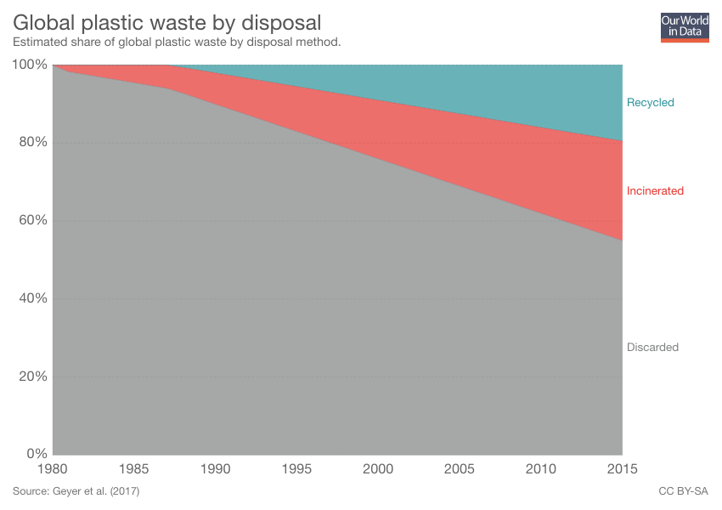

*Figure 1.* Global Plastic Waste by Disposal (Geyer, 2017).

This problem, as addressed by online recycling sources, is handled by explaining the importance of recycling and how the recycling process works. These sources each present different tools for recycling that individuals can use; the problem, however, is that none of these sources are consolidated into one single source, and are instead scattered across the internet. The primary limitation of such approaches is accessibility; users must go out of their way to search for recycling information from multiple sources. For example, an individual aiming to recycle an item must consult two sources: one to find out if the item is recyclable and another to see what the appropriate method of recycling is. An application that gathers all of this relevant information in one place is of extraordinary value; it saves users’ time and allows individuals to become more involved in the recycling process.

Individuals that take time out of their day to recycle often wonder whether certain items are recyclable. Additionally, it is common for people to be unsure of how to appropriately recycle particular items and question where to go to recycle unique items (i.e., computers and mechanical parts). With regards to this, our solution, *Our Green Routine*, is designed to make recycling easier and more accessible – enabling others to recycle correctly. Through a quick search on our web application, *Our Green Routine* will be able to show you a step-by-step process on how to appropriately recycle an item. Additionally, for those who are curious about how much they’re actually contributing towards keeping our environment green, *Our Green Routine* will also have the capability of tracking your carbon footprint.

Our target audience for this application is comprised of individuals that are invested in recycling. We aspire to create an easy-to-use and efficient web application in order to save users’ time and put all relevant information about recycling in Texas in one easy to access place for them.

**Approach:**

Our high-level approach is ultimately a web application which consolidates all the main services associated with recycling. These services include a database for recyclable items and pertinent recycling guides, a location tracker to help identify the nearest recycling centers, a section delineating Texas recycling regulations, a carbon footprint tracker, and a recycling-savings calculator. Additionally, users can create accounts to monitor their recycling and savings over time. By consolidating these services in one easily accessible location, we can encourage individuals to recycle. [3]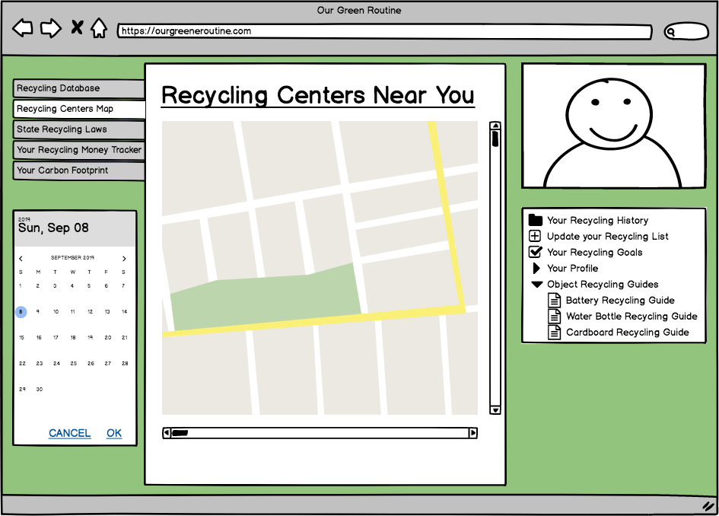

*Figure 2.* *Our Green Routine* - Mockup (Khanna and Ning, 2019).

The key difference between our application and others is that our application is comprehensive; it includes all of the pertinent services in one place – making recycling more accessible and efficient. Furthermore, we also include a carbon footprint tracker and a financial calculator to encourage users to recycle with this application.

Although *Our Green Routine* encourages recycling, there are certain limitations. The first limitation of our approach is being able to create a database large enough to cover every item that is potentially recyclable. This will either require the use of an API or the manual construction of a database (which will require time and effort). Another limitation pertains to the logistics of being able to carbon track individuals. It would involve knowing the statistical data of an item’s adverse environmental effects (which will require time and effort).

The structure of our application will be one general tool that has smaller subservices. *Our Green Routine* will be an application that aids users with the recycling process by accessing its aforementioned subservices. Each of these features is a key component to the ultimate recycling tool, and by being able to consolidate them all we have essentially unified all the essential aspects towards helping individuals recycle efficiently, correctly, and easily.

Indicate what data sources you would use. All projects must scrape data from several sources and store that data in a database; for your proposed project, describe this data and possible sources.

*Our Green Routine* will need large sets of data in order to operate functionally. We are hoping that we can use the *Earth911* API in order to fill our database with information on what items are recyclable, guides on how to appropriately recycle certain materials, and locations of recycling centers in Texas. We can also manually fill our databases from recycling data released by federal agencies (i.e., Environmental Protection Agency).

**Challenges and Risks:**

The single most serious challenge that we will encounter during the development process is obtaining relevant data for our database. In order to make *Our Green Routine* functionally useful, we must have a comprehensive database that covers a majority of recyclable materials. We are hoping to obtain this information from the Earth911 API, but if the API is insufficient, we must allocate time during the development lifecycle in order to manually implement our database. In order to mitigate the risk of creating our own comprehensive database that could affect the project life cycle, we can prematurely account for the time this task will take and update our database a little each day.

Hours Spent: 9 Hours

1. Sourced from <https://ourworldindata.org/faq-on-plastics>
2. Graphic taken from <https://ourworldindata.org/faq-on-plastics>
3. Mockup of *Our Green Routine*